**Fairfield Surgery Catchment Area**

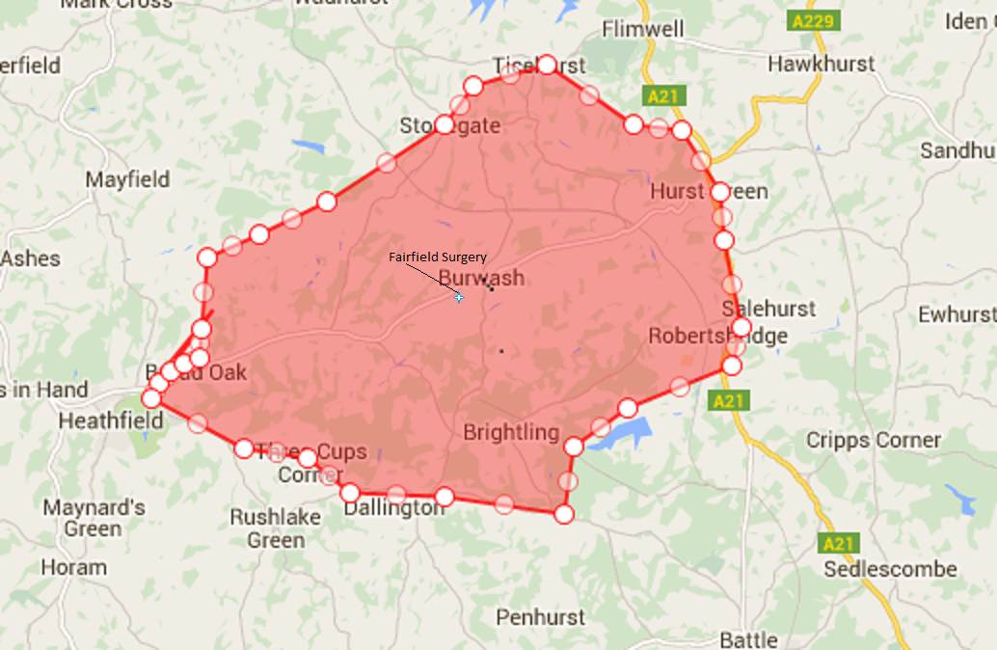

**FAIRFIELD SURGERY**

High Street,

Burwash,

East Sussex,

TN19 7EU

Dr Mark Robertson - Partner

Dr Simon Gilmore - Partner

Dr Claire Tickner – Salaried GP

Website: www.fairfieldsurgery.co.uk

Telephone: (01435) 882306



**The Clinical Care Commission Group (CCG)**

**Welcome to the Fairfield Surgery**

Fairfield Surgery was purpose build in 1992 to provide the residents of Burwash and the surrounding villages with a convenient and easily accessible means to consult their General Practitioners.

We are a rural, dispensing practice providing General Medical Services (GMS) to our population of around 4,200 patients. Our dedicated team of doctors and nurses carry out screening for certain diseases as well as promoting general health and wellbeing; they act as a patient’s advocate, supporting and representing a patient’s best interests to ensure they receive the optimal and most appropriate health and social care.

We provide a wide range of medical support services for all the family in a friendly and comfortable environment. The premises is on one floor and provides disabled access throughout the building.

The boundary for this surgery is displayed on a map found on the outside back cover of this booklet.

**Our Doctors**

**Partners**

Dr Mark Robertson - BSc (Hons) MBBS MRCCP

*Adult Safeguarding Lead, Caldicott Guardian*

Dr Simon Gilmore – BSc (Hons) MBChB MRCGP *Child Safeguarding Lead*

**Salaried Doctors**

Dr Claire Tickner – BMedSci, BMBS, MRCGP, DRCOG

The Clinical Care Commission Group is responsible for commissioning

local Medical Services in our area including the Out of Hours services

and hospitals.

Website: [**www.eastsussexccg.nhs.uk**](http://www.eastsussexccg.nhs.uk)

**Primary Care Network (PCN)**

Fairfield Surgery is a member of the Rural Rother Primary Care Network.

CQC logo

Fairfield Surgery, **CQC overall rating: Good**

**Friends of Burwash (FOB)**

An informal organisation established over 15 years ago. The Friends of Burwash support the surgery in any way they can, helping with driving patients both to appointments at the surgery or the hospital, etc. They also help with the funding of equipment not supplied by the NHS, which is beneficial to patients, either generally or specifically. If you would like to join, or can offer some time to FOBs, please collect a membership form from reception.

**Patient Participation Group (PPG)**

The practice has an active PPG which regularly engages with patients to seek feedback and comments about patient services. The PPG and members from the practice meet regularly to discuss services and initiatives. If you would like to become a member, or speak to one of the group, please ask at reception.

By working with the patient participation group and Friends of Burwash we seek to work with the local population and ensure that the patient’s ‘voice is heard’.

**Complaints**

The practice has an established in-house practice-based complaints procedures. If you wish to make a formal complaint, please write to Mrs Jo Shepherd, Practice Manager, who will conduct a full review in confidence and considerately using NHS Guidelines.

**Patient Suggestion Box**

Suggestions on how we can improve the services to our patients are most welcome. We currently participate in the friends and family test; this provides an opportunity to provide feedback anonymously. Feedback forms and a collection box are located in the reception waiting room. For additional information on comments and complaints, please see the leaflet in the waiting room.

**Practice Staff**

Practice support staff and administration of the practice is the responsibility of the Practice Manager, Mrs Joanna Shepherd.

The reception staff have a full knowledge of the services the practice has to offer and will be pleased to answer any questions.

**Practice Nurses**

Debbie Simkins - RGN

Elaine Buckland - RGN

The practice nurses are available by appointment. They carry out a variety of procedures and are also available for health information and advice.

**Health Care Assistant**

Jayne Harrison – is available for blood tests by appointment only.

**First Contact Physiotherapist**

Please ask reception to book an appointment with thephysiotherapist for all acute musculoskeletal issues.

**Midwife team**

The midwife holds an ante natal clinic every other week at the surgery**.**[**www.esht.nhs.uk/service/maternity/**](http://www.esht.nhs.uk/service/maternity/)

**Social Prescriber**

Are available to assist our patients with a multitude of issues, which impact health and wellbeing. [www.southdown.org/CommunityConnectors](http://www.southdown.org/CommunityConnectors)

**District Nurse**

Community nursing services can be accessed via referral from your GP. Please ask reception for further information.

**Health Visitor**

The Health visitors are not based at the surgery but clinics can be accessed by calling 01424 726446

.

**How to Register**

As long as you live within the practice designated area, you can apply to register with this practice. The reception staff will provide you with the necessary forms and health questionnaires to complete for each person requiring registration. You can take these forms away with you if you prefer. Once the completed forms are received at the practice and signed off by the doctors, you are then registered with this practice: we will obtain your medical records from your previous GP.

We invite all new patients, 18 years and over, to attend a health check with one of our practice nurses, and if you are on any regular medication you may also need to see a doctor. Please bring any evidence of medication you are on with you when you register.

**Home Visits**

Home visits will be accepted for those who are unable to attend the surgery due to their medical condition. Social reasons are not considered acceptable for a home visit by the doctor. All requests for home visits must be received before 10.30 a.m. unless urgent. We would ask you to pass the facts to the receptionist so that they can be passed to the visiting doctor. A doctor may telephone you in advance of visiting.

**Surgery Opening Hours**

Monday to Friday 08:25 – 12:30 14:00 – 18:30

**Telephone lines**

Monday to Friday 08:00 – 12:30 13:30:00 – 18:30

**Dispensary**

Monday to Friday 08:25 – 12:30 14:00 – 17:30

**We are closed all day Saturday, Sunday, Bank and Public Holidays.**

**For Advice Out of Hours and Out of Hours GP Service**

Out-of-hours cover is provided by the doctors in conjunction with NHS 111. When the surgery is closed, please phone the out of hour’s service on

**111** or visit the website: **111.nhs.uk**

Please remember if your problem is a life-threatening emergency, telephone **999.**

**Our Support Team**

**Outside of normal opening hours**

**If you have a prescription.**

If your local pharmacy is closed, use the link to find other nearby pharmacies and their opening hours. Some are open until midnight or later, even on public holidays.

<http://www.nhs.uk/Service-Search/Pharmacy/LocationSearch/10>

If you would prefer to speak to someone first, call NHS 111 on 111. They will also be able to look up an out-of-hours pharmacy or service in your area for you.

**If you don’t have a prescription**

If you run out of prescription medicines and don’t have a prescription with you, you may be able to get an emergency supply without a prescription from a pharmacy. It’s a good idea to take along your medicine’s packaging with you, or your repeat prescription list. The pharmacist will need to be assured of all these things before they supply a prescription-only medicine in an emergency, without a prescription.

**Zero Tolerance**

The practice supports the government’s NHS Zero Tolerance Campaign. Violence and abuse, whether it be physical or verbal to practice staff and/or patients, as well as damage to the practice premises or any equipment therein, will not be tolerated and may result in you being removed from the practice register. Violent patients will be reported to the police and removed from the practice register.

**Freedom of Information**

The Freedom of Information Act 2000 obliges the practice to produce a Publication Scheme. A Publication Scheme is a guide to the “Classes” of information the practice intents to routinely make available. This scheme is available by asking at reception.

**Private Services**

In addition to our NHS services we can also provide a range of fee-based, non-NHS services for example, holiday cancellation forms, fire arms certificates. A list of these and associated fees can be obtained from reception or our website [www.fairfieldsurgery.co.uk](http://www.fairfieldsurgery.co.uk).

**Practice Dispensary and Repeat Prescriptions**

We are a dispensing practice which means if you live more than one mile from your nearest chemist, as the crow flies, you can collect your medication from the surgery. The practice dispensary is open 08.25 to 17.30pm. The practice employs qualified dispensers and training dispensary assistants. The dispensary is licenced to dispense those medicines prescribed to you, whether that be from a practice clinician or a hospital consultant. We cannot sell ‘over the counter’ medicines or products to you.

For patients requiring regular medication, a computerised repeat prescription printout will be issued by the doctor. This should be handed in at reception or posted to the surgery, with clear instructions as to the items required. You can also order online via the patient access facility on our website. We require 4 clear working days to order, process, and check the items before your collect them. Any prescription charges must be paid at this time or proof of exemption shown. Requests for medication will not be taken over the telephone, as this can result in errors being made.

**HOW TO OBTAIN MEDICINES URGENTLY**

**During normal opening hours**

**Dispensing Patients** If you run out of your medicines during normal opening hours, please speak to the surgery dispensary who will help you with your issue.

**Non Dispensing Patients** will need to collect the paper prescription from the Surgery.

If you run out of medicines while you’re away from home, you may be able to have a consultation with a local GP and get a prescription for a limited supply of medicines or attend an NHS walk-in-centre.

If they are not satisfied that the medicine and dose is appropriate for you, they may not supply the medicine.

**GP Walk in centres out of hours**

NHS walk-in centre may be able to organise a GP consultation and in some cases will prescribe medicine after you’ve seen a nurse. Some walk-in centres are open from early morning to late evening, seven days a week, 365 days a year.

**Disclosure of Patient Information**

We ask for information about you so that you can receive the best possible care and treatment. We keep this information, together with details of your care, to ensure that your doctor or nurse has accurate and up-to-date knowledge about you. It may also be necessary if we or a colleague need to see you again. There are times when we have to pass on information about you to other people such as hospitals, Health Authorities, CCG and Social Services. This is always done confidentially or by removing your identifying details when they are not essential.

Everyone working for the NHS have a legal duty to maintain the highest level of confidentiality about patient information.

Details may also be given to third parties, such as insurance companies and solicitors, but this is never done without your explicit and written consent.

**Summary Care Record**

Your Summary Care Record is a copy of key information held in your GP record. It provides authorised healthcare staff with faster, secure access to essential information when you attend hospital or A&E or out of hours. You can choose to add additional information including medical history, immunisations, long term conditions and any healthcare preferences. You can also chose to opt out of this service. For further information please speak to a receptionist.

**Accessing your Medical Records**

If you require access to your medical records you must complete an Access to Medical Records Form. You will be asked to provide photographic identification to verify you are the patient.

**Results**

For reasons of confidentiality, results will only be given to the patient or their guardian. Please phone after 10:00

**Confidentiality**

All staff sign a Confidentiality Agreement which is strictly adhered to. Patients requesting to view their medical records can do so by applying in writing to the practice manager.

**Privacy**

As data controllers, GPs have fair processing responsibilities under the Data Protection Act and GDPR law 2018. This means ensuring that your personal confidential data (PCD) is handled in ways that are safe, transparent and what you would reasonably expect.

**Services provided by the Practice**

Cervical Smears Post Natal Check

Asthma Checks Chronic Diseases Reviews

Diabetic Checks Childhood Vaccinations

Childhood Checks ECGs

Diet and General Wellbeing Phlebotomy

Minor Injuries 24hour Blood Pressures

Family Planning and Emergency Contraception

NHS Health Checks - NHS Health Checks are for patients aged between 45 years and 75 without any pre-existing health conditions.

All of the above routine services will be carried out in the surgery by appointment with either the doctor or practice nurse. The Practice offers a range of daily appointments from 08:30 - 12:00 and 15:00- 17:30. To obtain an appointment please drop in to the surgery or phone **01435 882306.**